Enhancing BOPF and Creating Custom Determination:

* BOBX Transaction:  
  A screenshot of a computer

  Description automatically generated
* Create a Constant Interface with the following interface: /BOBF/IF_LIB_CONSTANTS
* Set the Super Bus. Object

* Create a Determination  
  A screenshot of a computer

  Description automatically generated

|  |
| --- |
| class ZCL_TU_D_ROOT definition  public  inheriting from /SAPYL/CL_TU_D_BASE  final  create public  global friends /SAPYL/CL_TU_D_BASE .  public section.  methods DET_ROOT_BEFORE_SAVE  importing  !IS_CTX type /BOBF/S_FRW_CTX_DET  !IT_KEY type /BOBF/T_FRW_KEY  !IO_READ type ref to /BOBF/IF_FRW_READ  !IO_MODIFY type ref to /BOBF/IF_FRW_MODIFY  exporting  !EO_MESSAGE type ref to /BOBF/IF_FRW_MESSAGE  !ET_FAILED_KEY type /BOBF/T_FRW_KEY .  methods /BOBF/IF_FRW_DETERMINATION~EXECUTE  redefinition .  protected section.  methods GET_DET_METHOD_NAME  redefinition .  private section.  ENDCLASS.  CLASS ZCL_TU_D_ROOT IMPLEMENTATION.  METHOD /bobf/if_frw_determination~execute.  DATA: lt_tus TYPE TABLE OF /sapyl/s_yard_tu_root_c,  lt_cf TYPE /bobf/t_frw_name,  ls_cf TYPE LINE OF /bobf/t_frw_name.  io_read->retrieve(  EXPORTING  iv_node = /sapyl/if_yard_tu_c=>sc_node-root " Node Name  it_key = it_key " Key Table  IMPORTING  eo_message = eo_message " Message Object  et_data = lt_tus " Data Return Structure  et_failed_key = et_failed_key " Key Table  ).  IF lt_tus IS NOT INITIAL.  DATA(ls_tu) = lt_tus[ 1 ].  "Update NAME1 Field  SELECT SINGLE name1  FROM lfa1  INTO ls_tu-name1  WHERE lifnr = ls_tu-tdlnr.  IF sy-subrc = 0.  ls_tu-name1_t = ls_tu-name1.  ENDIF.  ls_tu-tdlnr_t = ls_tu-tdlnr.  ls_cf = 'TDLNR'.  APPEND ls_cf TO lt_cf.  ls_cf = 'NAME1'.  APPEND ls_cf TO lt_cf.  ls_cf = 'TDLNR_T'.  APPEND ls_cf TO lt_cf.  ls_cf = 'NAME1_T'.  APPEND ls_cf TO lt_cf.  TRY.  io_modify->update(  EXPORTING  iv_node = /sapyl/if_yard_tu_c=>sc_node-root " Node Name  iv_key = it_key[ 1 ]-key " Key  is_data = REF #( ls_tu ) " Data  it_changed_fields = lt_cf " List of Names (e.g. Fieldnames)  ).  CATCH /bobf/cx_frw_contrct_violation. " Caller violates a BOPF contract  ENDTRY.  ENDIF.  ENDMETHOD.  METHOD det_root_before_save.  ENDMETHOD.  METHOD get_det_method_name.  rv_method_name = 'DET_ROOT_BEFORE_SAVE'.  ENDMETHOD.  ENDCLASS. |

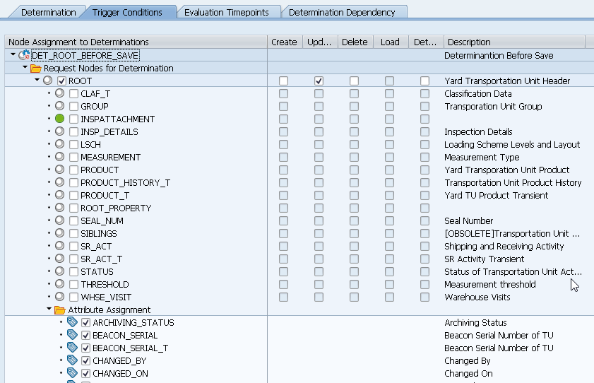

Generate and save 